THE UNIVERSITY OF DODOMA

COLLEGE OF INFORMATICS AND VIRTUAL EDUCATION

DEPARTMENT OF COMPUTER SCIENCE AND ENGINEERING
COURSE NAME: NETWORK FORENSICS
COUSE CODE: IA 311
LAB ASSIGNMENT: LAB NO9
GROUP NO 4
NAME | REGISTRATION NUMBER
HENRY SELEMAN | T22-03-00295
JIMSON MAHENGE | T22-03-08372
PUDENCIANA KIYEGA | T22-03-11584
PETRO MOHERE | T22-03-02116

- What is the IP address of the client?
ANSWER
The IP address of the client is 192.168.1.100
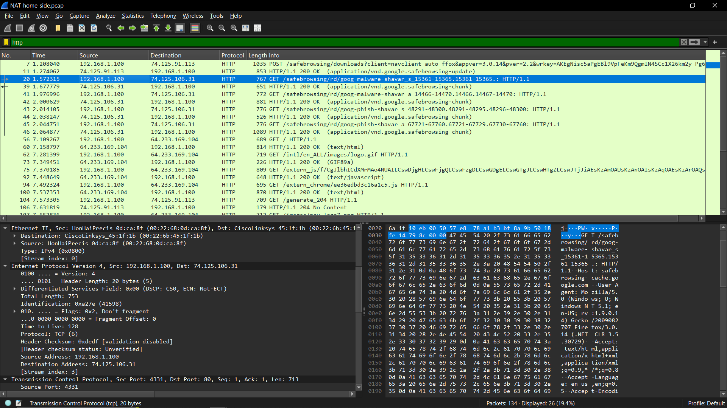

- The client actually communicate with several different Google servers in order to implement “safe browsing.” (See extra credit section at the end of this lab). The main Google server that will serve up the main Google web page has IP address 64.233.169.104. In order to display only those frames containing HTTP messages that are sent to/from this Google, server, enter the expression “http && ip.addr == 64.233.169.104” (without quotes) into the Filter: field in Wireshark .
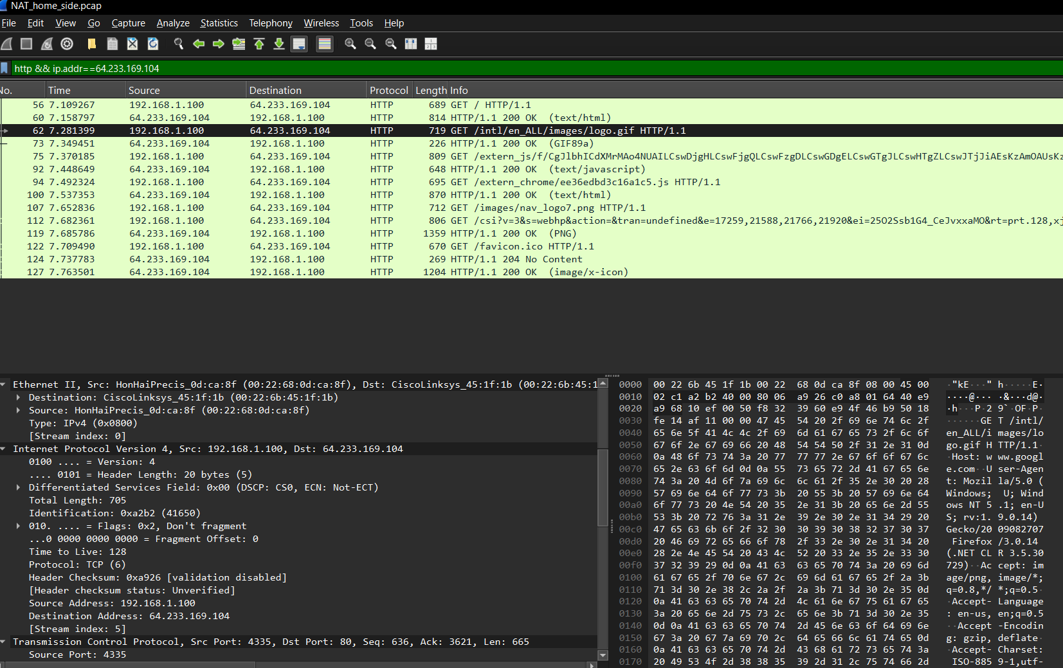

- Consider now the HTTP GET sent from the client to the Google server (whose IP address is IP address 64.233.169.104) at time 7.109267. What are the source and destination IP addresses and TCP source and destination ports on the IP datagram carrying this HTTP GET?.
ANSWER
Source IP address: 192.168.100.1
Destination IP address: 64.233.169.104
TCP source port is: 4335
TCP destination port is: 80

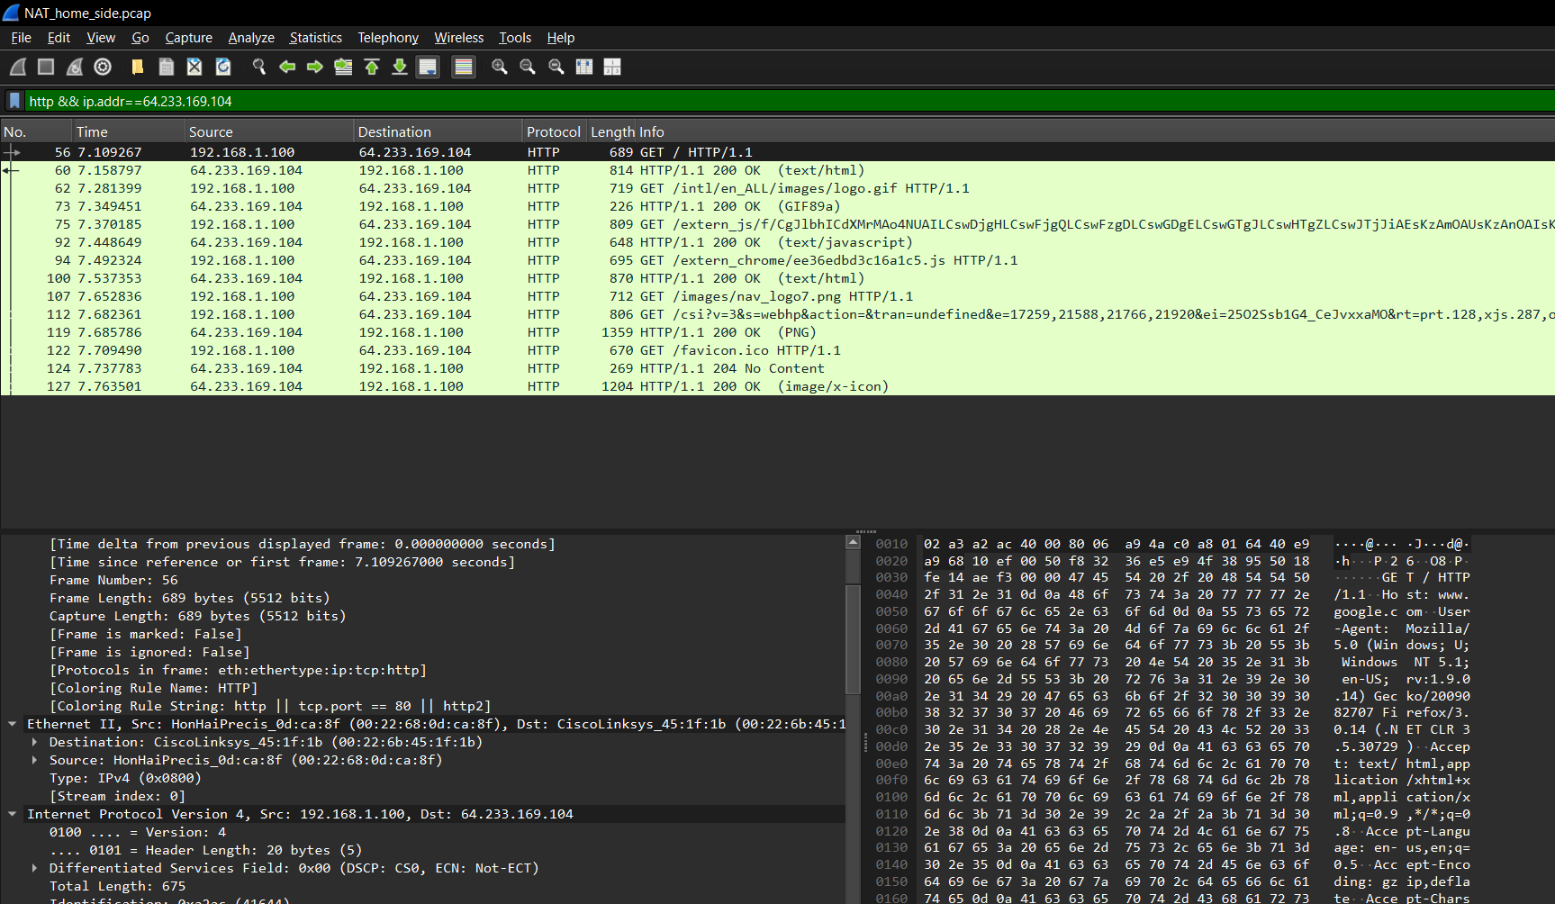

- At what time is the corresponding 200 OK HTTP message received from the Google server? What are the source and destination IP addresses and TCP source and destination ports on the IP datagram carrying this HTTP 200 OK message?
Answer
At a time of 0.232656 the 200 OK HTTP message received from google
Source Ip address is: 74.125.91.113
Destination Ip address is: 71.192.34.104

TCP source port is: 80
TCP destination port is: 4330
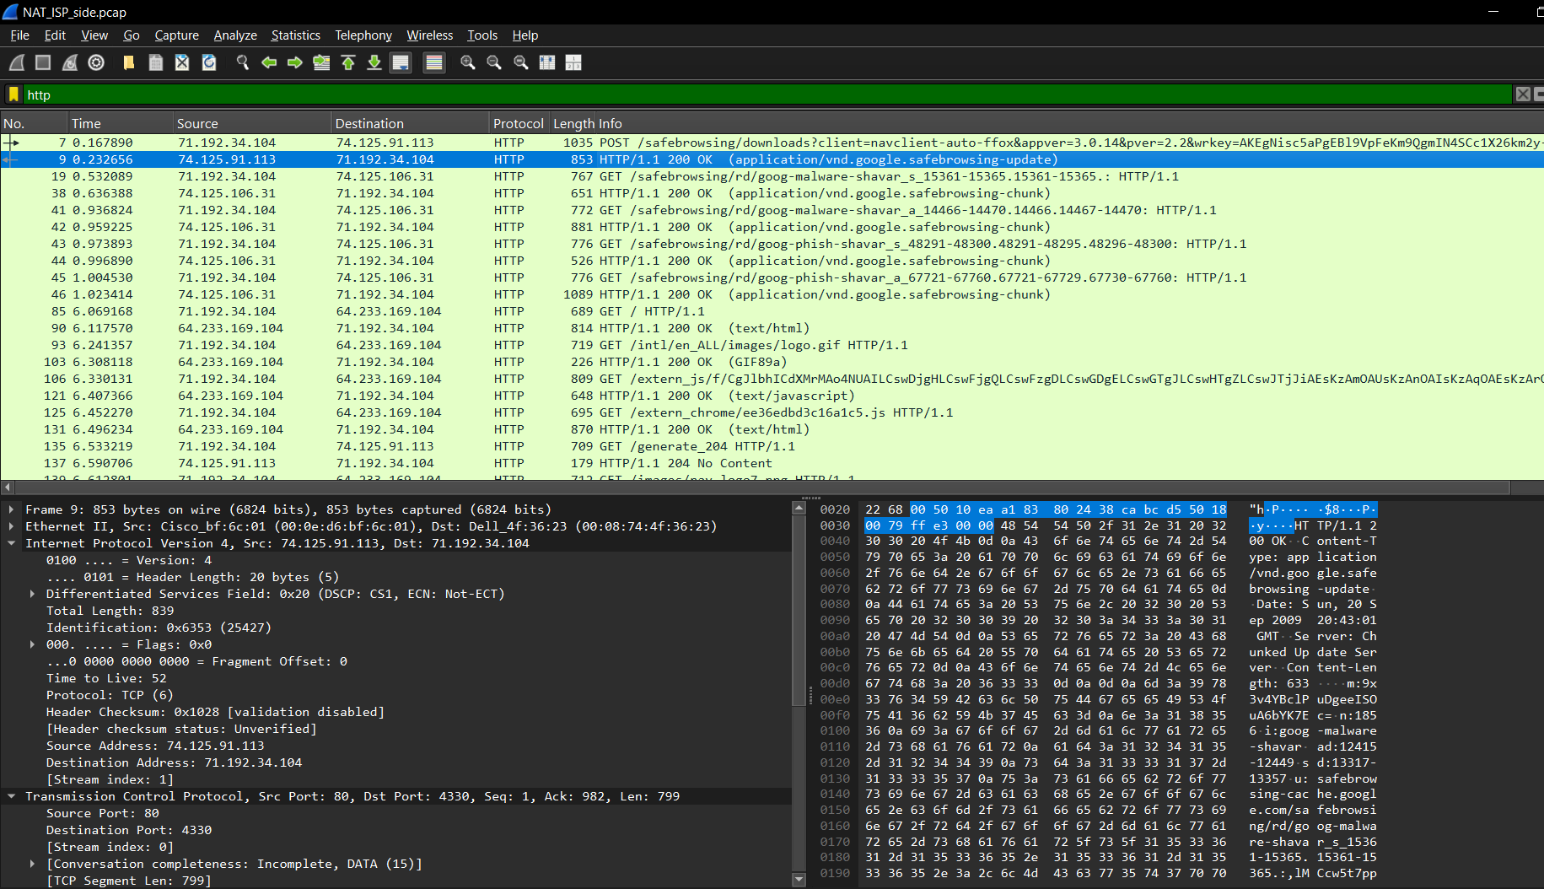

- Recall that before a GET command can be sent to an HTTP server, TCP must first set up a connection using the three-way SYN/ACK handshake. At what time is the client-to-server TCP SYN segment sent that sets up the connection used by the GET sent at time 7.109267? What are the source and destination IP addresses and source and destination ports for the TCP SYN segment? What are the source and destination IP addresses and source and destination ports of the ACK sent in response to the SYN. At what time is this ACK received at the client? (Note: to find these segments you will need to clear the Filter expression you entered above in step 2. If you enter the filter “tcp”, only TCP segments will be displayed by Wireshark).
In the following we’ll focus on the two HTTP messages (GET and 200 OK) and the TCP SYN and ACK segments identified above. Our goal below will be to locate these two HTTP messages and two TCP segments in the trace file (NAT_ISP_side) captured on the link between the router and the ISP. Because these captured frames will have already been forwarded through the NAT router, some of the IP address and port numbers will have been changed as a result of NAT translation. Open the NAT_ISP_side. Note that the time stamps in this file and in NAT_home_side are not synchronized since the packet captures at the two locations shown in Figure 1 were not started simultaneously. (Indeed, you should discover that the timestamps of a packet captured at the ISP link is actually less that the timestamp of the packet captured at the client PC).

Answer
Source IP address: 71.192.34.104
Destination IP address: 64.233.169.104
Source port is: 4337
Destination port is: 80
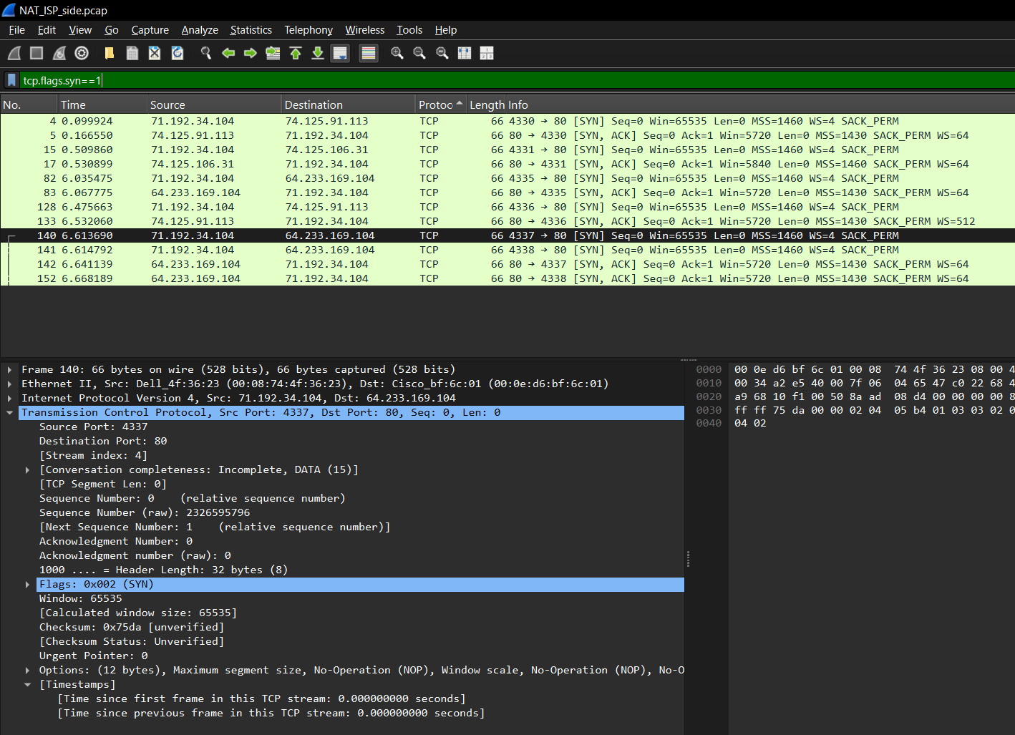

Time stamp
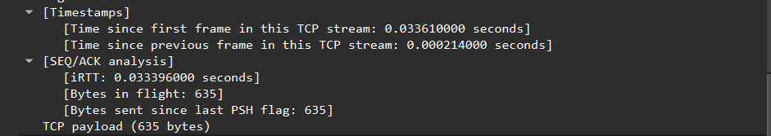

- In the NAT_ISP_side trace file, find the HTTP GET message was sent from the client to the Google server at time 7.109267 (where t=7.109267 is time at which this was sent as recorded in the NAT_home_side trace file). At what time does this message appear in the NAT_ISP_side trace file? What are the source and destination IP addresses and TCP source and destination ports on the IP datagram carrying this HTTP GET (as recording in the NAT_ISP_side trace file)? Which of these fields are the same, and which are different, than in your answer to question 3 above?
ANSWER
- Same:
  - Destination IP (Google server: 64.233.169.104).
  - Destination Port (HTTP port 80).
- Different:
  - Source IP: NAT translates the client's original IP to a different public IP in the NAT_ISP trace. Likely different due to NAT.
  - Source Port: The NAT process changes the source port for outgoing connections.
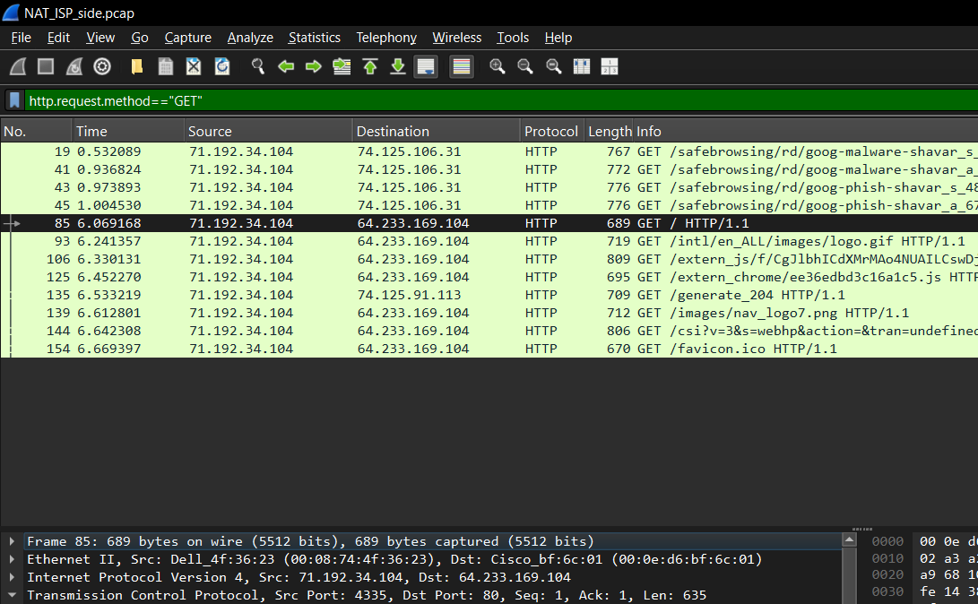
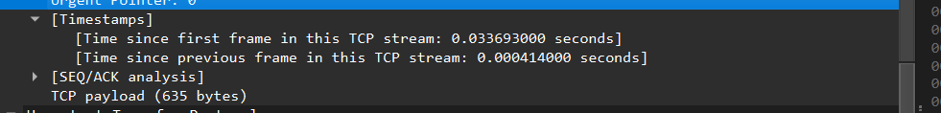
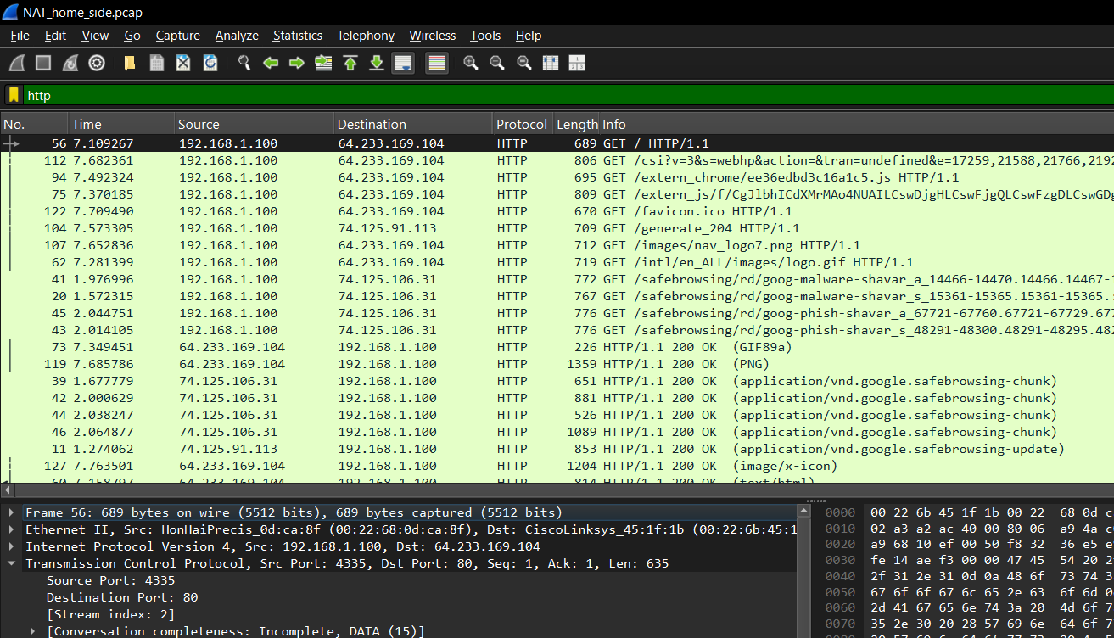
- Are any fields in the HTTP GET message changed? Which of the following fields in the IP datagram carrying the HTTP GET are changed: Version, Header Length, Flags, Checksum. If any of these fields have changed, give a reason (in one sentence) stating why this field needed to change.
ANSWER
Checksum changes because the source IP was modified by NAT).
- If any fields are changed, they are likely modified by the NAT process, particularly:
  - Checksum: Changes due to NAT modifying the source IP address.
  - Flags: Could change if fragmentation occurs during NAT transmission (though this is less common).
- Other fields like Version and Header Length are typically not affected by NAT.
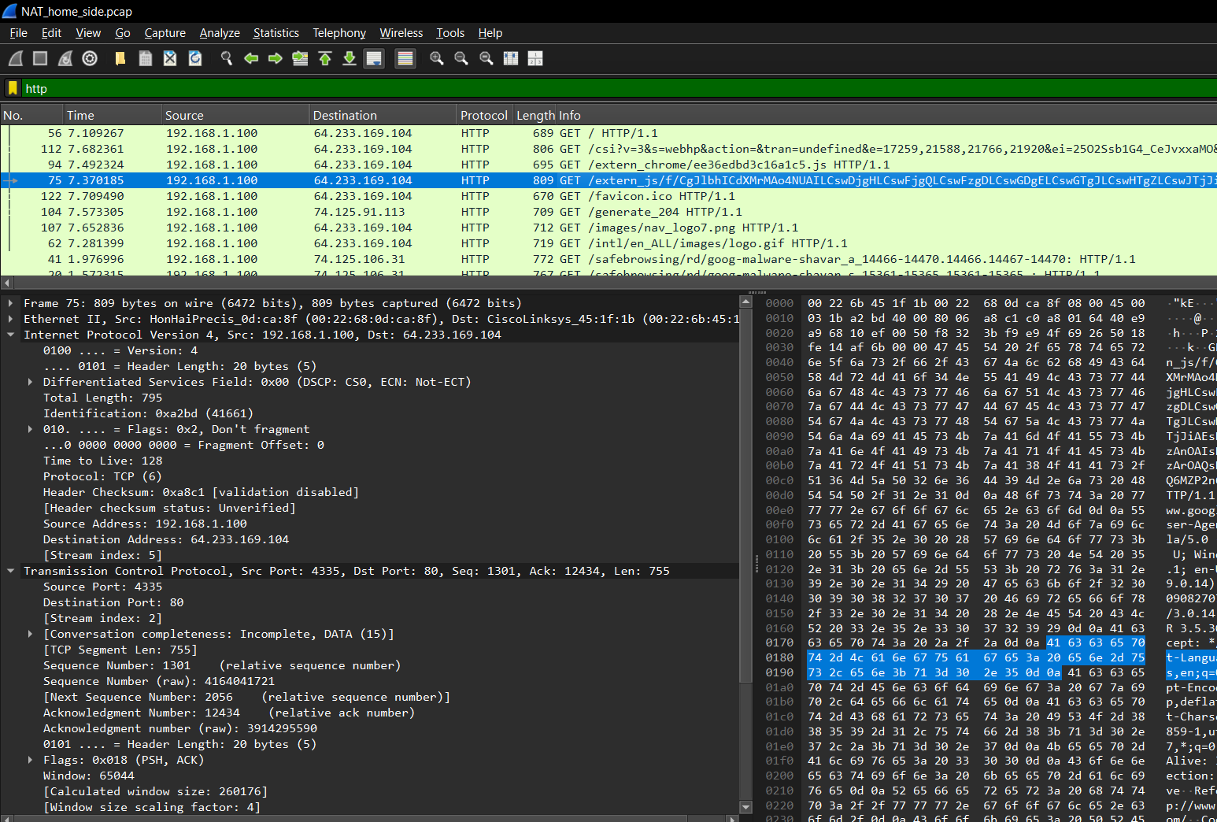
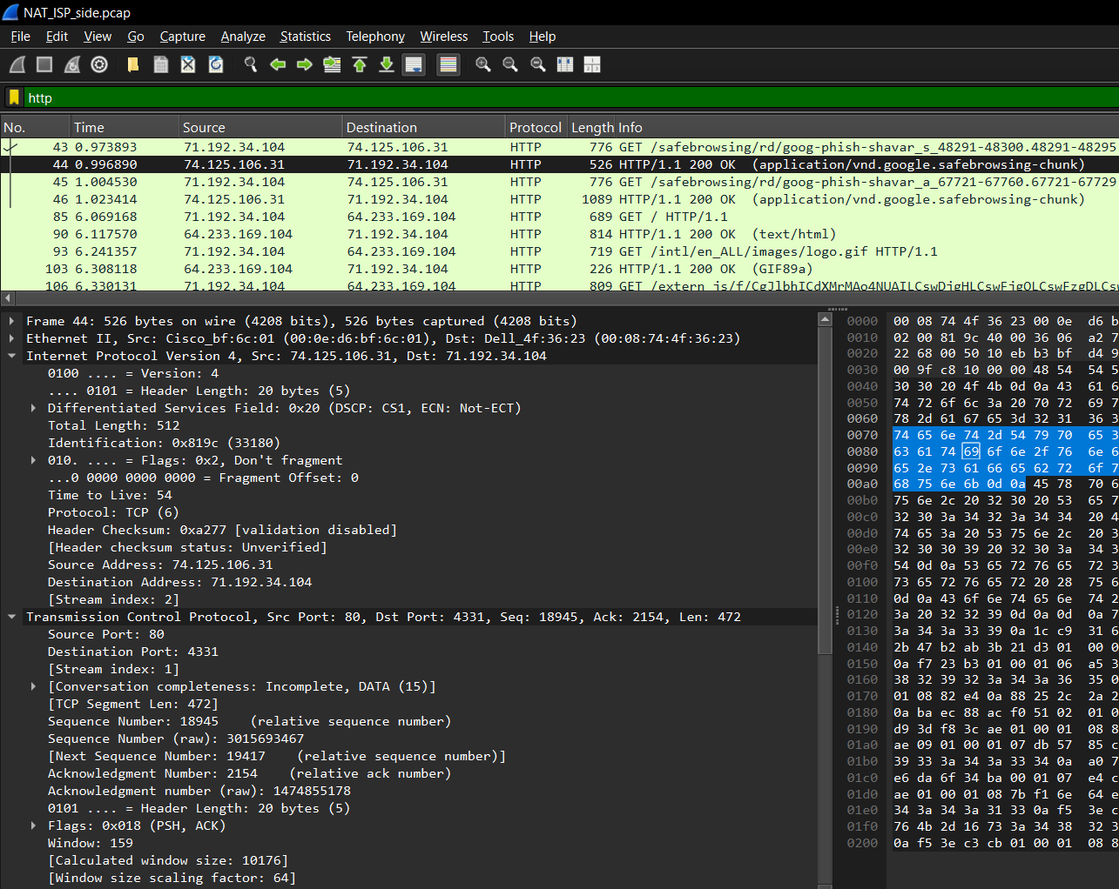

- In the NAT_ISP_side trace file, at what time is the first 200 OK HTTP message received from the Google server? What are the source and destination IP addresses and TCP source and destination ports on the IP datagram carrying this HTTP 200 OK message? Which of these fields are the same, and which are different than your answer to question 4 above?
ANSWER
- Same fields:
  - Source IP: The Google server’s IP (74.125.91.113) remains unchanged.
  - TCP Source Port: The Google server's HTTP port (80) remains unchanged.
- Different fields:
  - Destination IP: The client’s IP (71.192.34.104) in NAT_home is replaced with the NAT-translated IP in NAT_ISP.
  - TCP Destination Port: The client’s source port (4330) in NAT_home is replaced with the NAT-translated port in NAT_ISP.

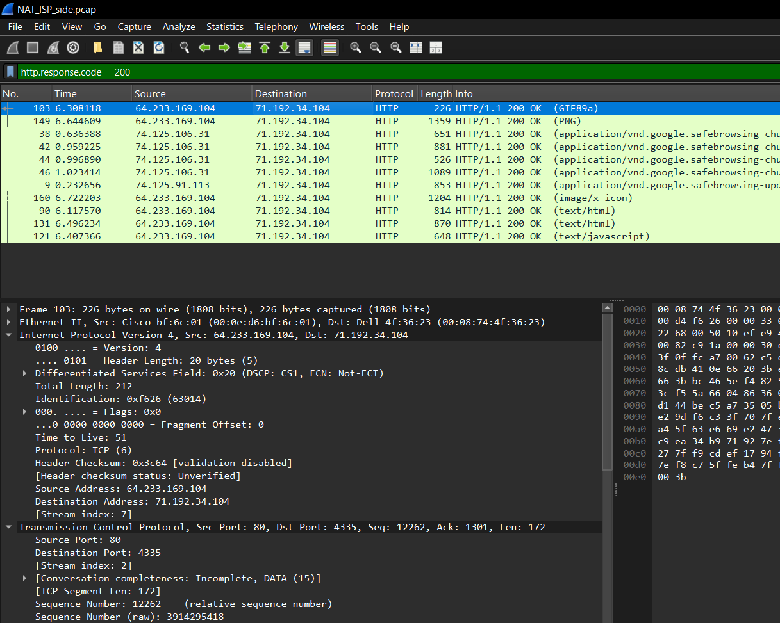

- In the NAT_ISP_side trace file, at what time were the client-to-server TCP SYN segment and the server-to-client TCP ACK segment corresponding to the segments in question 5 above captured? What are the source and destination IP addresses and source and destination ports for these two segments? Which of these fields are the same, and which are different than your answer to question 5 above?
ANSWER
Source IP address: 71.192.34.104
Destination IP address: 74.125.106.31
Source port is: 4331
Destination port is: 80

- Same fields:
  - Source IP for SYN: The destination (Google servers IP) remains the same.
  - Destination Port for SYN and ACK: The server port 80 is the same.
- Different fields:
  - Source IP (for SYN): The client’s original IP in NAT_home side is replaced with the NAT-translated public IP.
  - Source Port (for SYN): The client’s original source port is replaced with the NAT-translated port.
  - Destination IP (for ACK): The client’s original IP is replaced with the NAT-translated public IP.
  - Destination Port (for ACK): The original client port is replaced with the NAT-translated port.

