INITIALIZING COMMUNICATION BETWEEN TWO CLIENTS USING GPG

To set up two clients to communicate securely using GPG (GNU Privacy Guard), follow these clear steps. This process involves generating GPG keys, exchanging public keys, and encrypting/decrypting messages.

Step 1: Install GPG

Ensure GPG is installed on both clients.

On Debian/Ubuntu:
sudo apt update
sudo apt install gnupg

Step 2: Generate GPG Keys

Each client needs to generate their own GPG key pair.

1. Generate Keys:
Run the following command on Client A:

gpg --full-generate-key
```
- Choose the default options (RSA and RSA).
- Set the key size (2048 or 4096 bits is recommended).
- Specify the expiration date.
- Enter your name and email address.
- Set a passphrase.

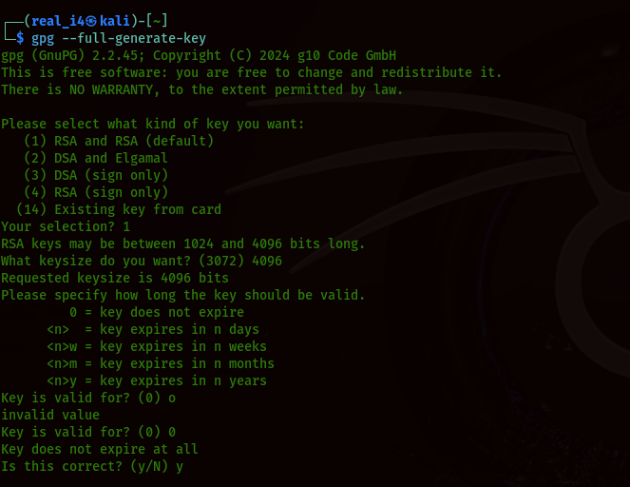
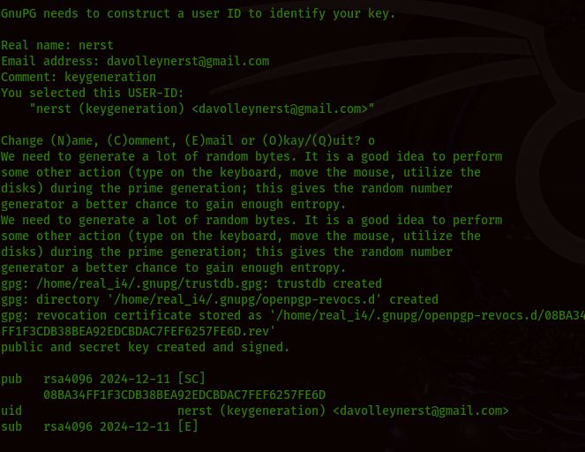

2. Repeat on Client B:
Perform the same steps on Client B to generate their GPG key pair.

Step 3: List and Export Public Keys

1. List Keys
On both clients, list the keys to find the key ID:
gpg --list-keys

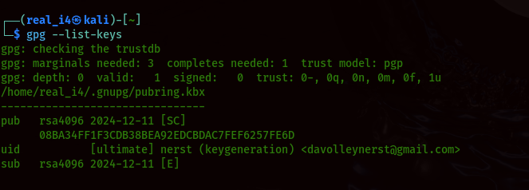

2. Export Public Key:
Export the public key to a file on Client A:

gpg --export -a "Your Name" > client_a_public_key.asc

Repeat this step on Client B to export their public key:

gpg --export -a "Their Name" > client_b_public_key.asc

Step 4: Exchange Public Keys

Each client needs to send their public key file to the other.

- Send Client A's Public Key to Client B**.
- Send Client B's Public Key to Client A**.

You can use email, USB drive, or other secure methods for this.

Step 5: Import Public Keys

Each client needs to import the other's public key.

1. Import Public Key on Client A:

gpg --import client_b_public_key.asc

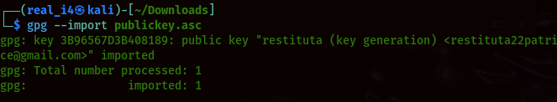

2. Import Public Key on Client B:

gpg --import client_a_public_key.asc

Step 6: Encrypt and Decrypt Messages

1. Encrypt a Message (Client A):
Use the following command to encrypt a message for Client B:

create a message
echo “ Hello Everyone” > me.txt

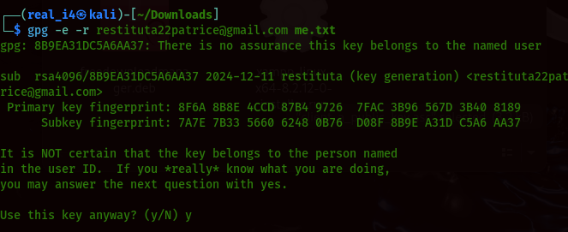

2. Send the Encrypted Message:
Client A sends the “me.txt” file to Client B.

3. Decrypt the Message (Client B):
Upon receiving the message, Client B decrypts it using:

gpg --decrypt rq.txt.pgp

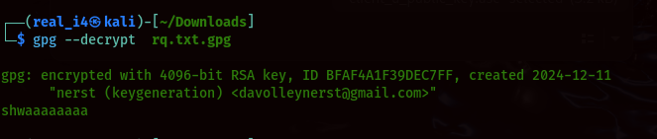

Summary of Steps
1. Install GPG on both clients.
2. Generate GPG keys on each client.
3. Export and exchange public keys.
4. Import public keys on each client.
5. Encrypt messages using the recipient's public key.
6. Decrypt received messages using your private key.

