THE UNIVERSITY OF DODOMA

COLLEGE OF INFORMATICS AND VIRTUAL EDUCATION
DEPARTMENT OF COMPUTER SCIENCE AND ENGINEERING (CSE)
LAB ONE: EMAIL FORENSICS
PROGRAM: BSc-CNISE
COURSE: IA 418
SUBMISSION DATE : 12th January 2025

GROUP PARTICIPANTS
NAME | REGSTRATION NUMBER
NYAMIZI SHIJA | T22-03-02725
PUDENCIANA P. KIYEGA | T22-03-11584
EMMANUEL WOLFGANG | T22-03-09178
GEORGE KALAMU | T22-03-08400

QUESTION:
On a Linux Machine (virtual or physical), install and configure a mail server on a specific domain, with a Graphical User Interface to send and receive emails. Create email accounts, send emails from one user to another, and observe email header details associated with the email. Where is the log file associated with email transactions? Can you be able to track email details obtained from email header analysis to the log file?

DEMOSTRATIONS.
Step 1: First update the Linux Machine , then install postfix mail server and configure it as shown below.
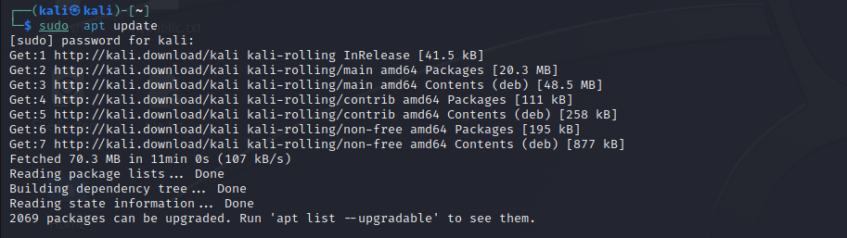

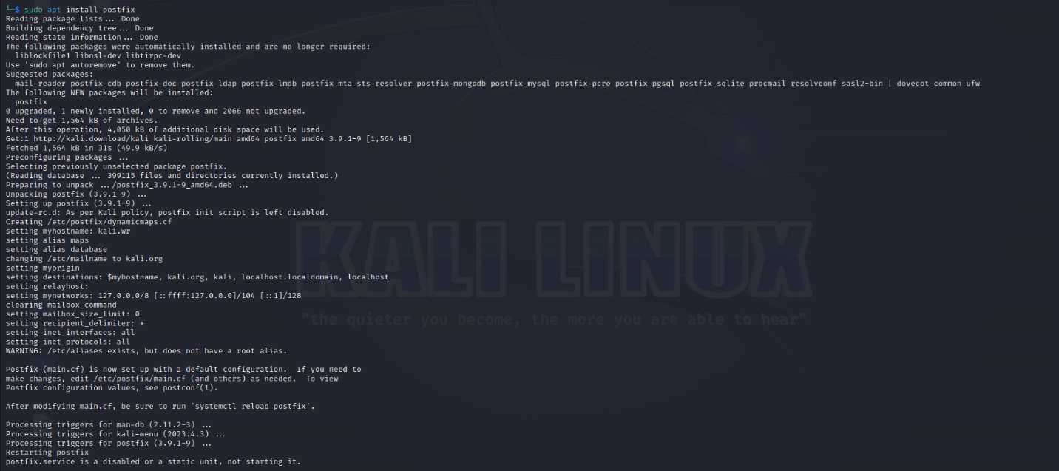

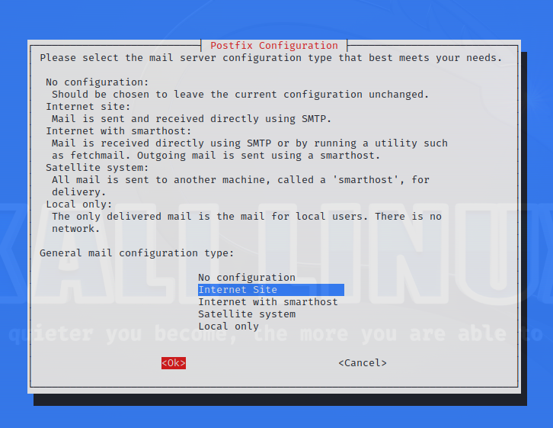

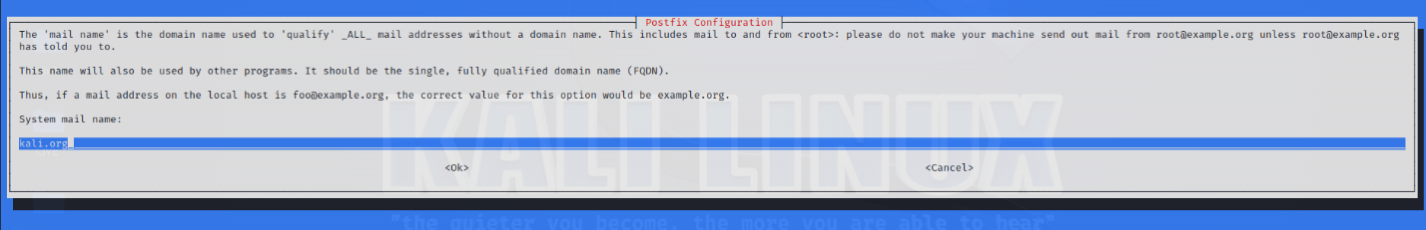

Step 2: Second is to start postfix in order to make it active also you can enable it so as to make postfix start automatic after rebooting the machine
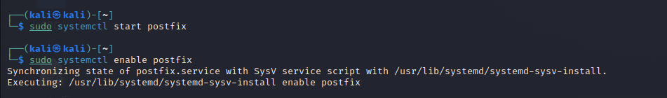
Then you can check the status of the mail server to look if postfix is active runnig, as shown below.
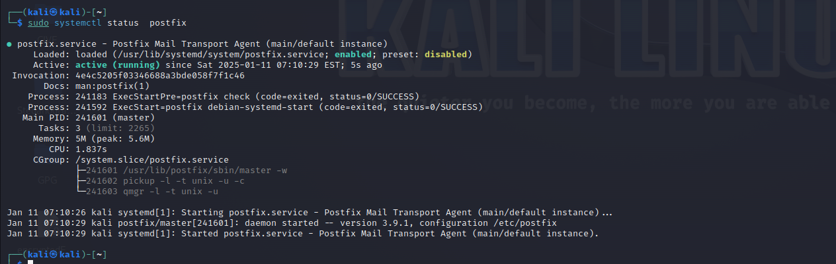

Step 3: Third is Mutt installation, this is the Graphical User Interface client to send and receive emails. Then Run it to start creating the email accounts, as shown below.
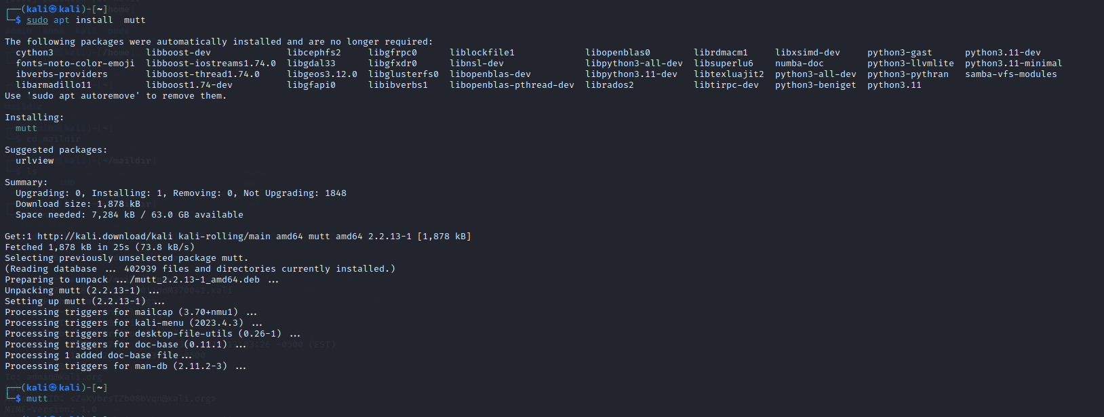

After running the mutt command ,the graphical user interface will be opened as seen below.
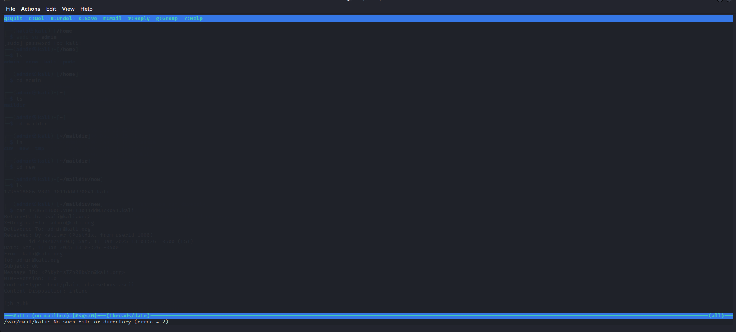

Click ‘m’ to start writing your email message, then it will allow you to enter the name of the one you need to sent emails the click enter .
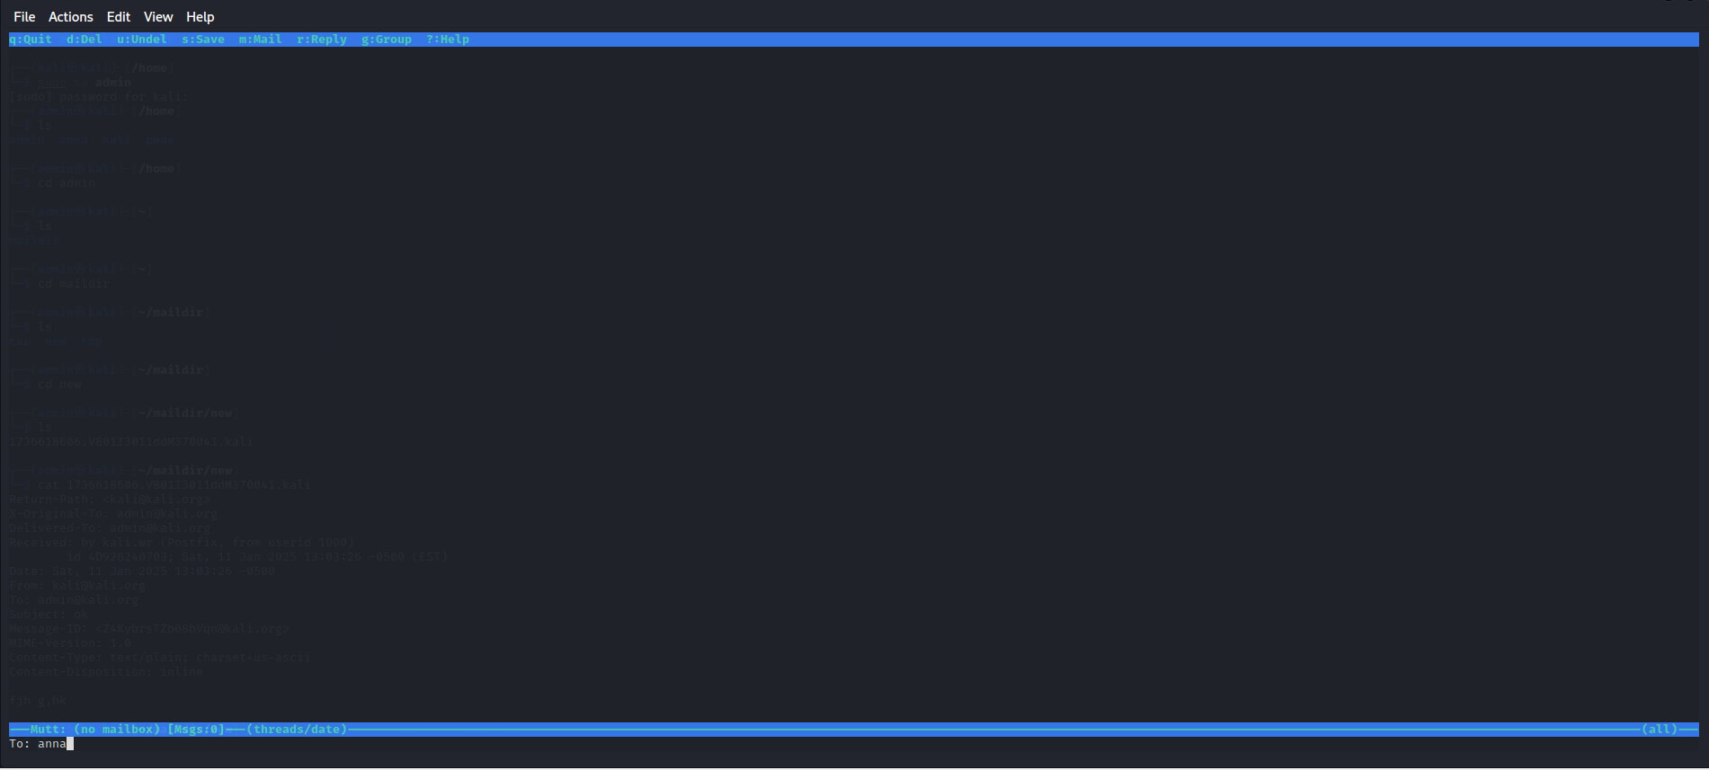

Here you write the message you need to send t your user then click enter
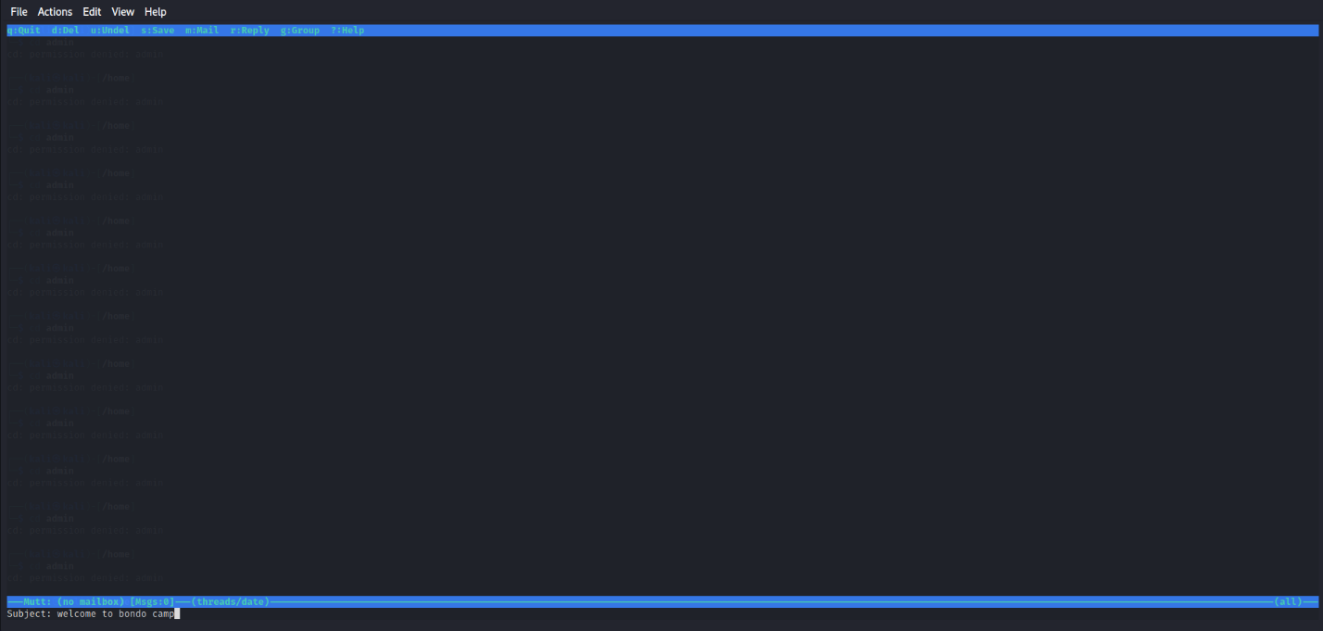

Step 4: Fourth is to send the email to user Anna, here you need to click “y”. Then automatic mail will be sent as shown below.
Note that: Make sure you create the user before start sending emails, the command to add user is “adduser”.
Example:
$ sudo adduser anna

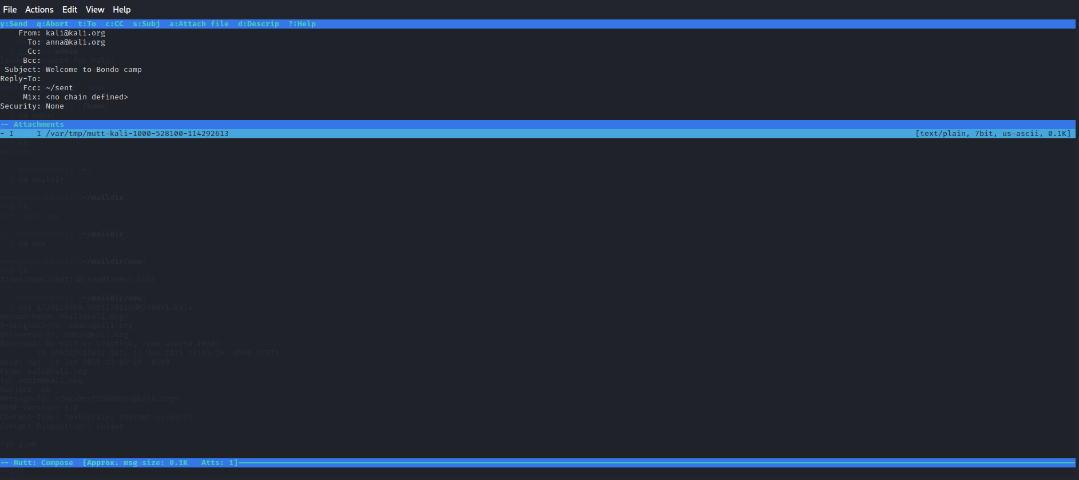

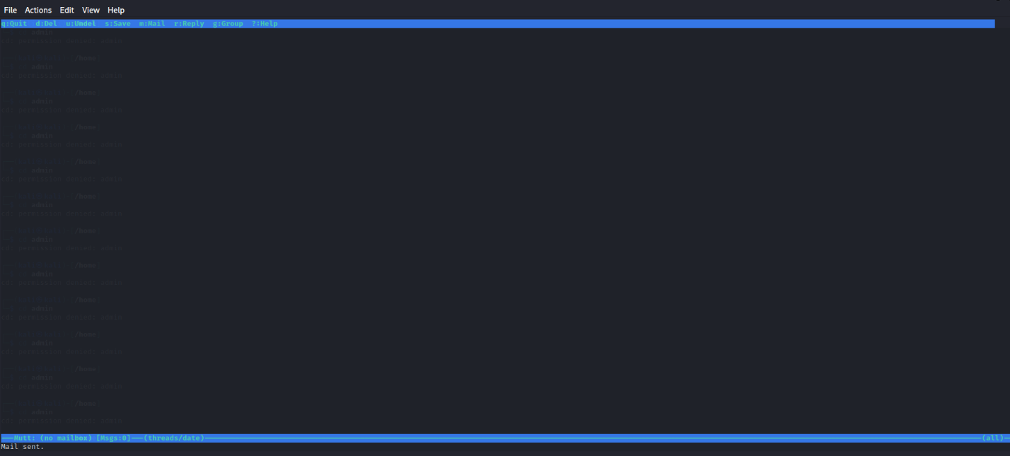
Step 5: The observation of email header details associated with the email, here we give our user anna permission so as we can be able to see the emails sent by kali@kali.org. These are the steps below:
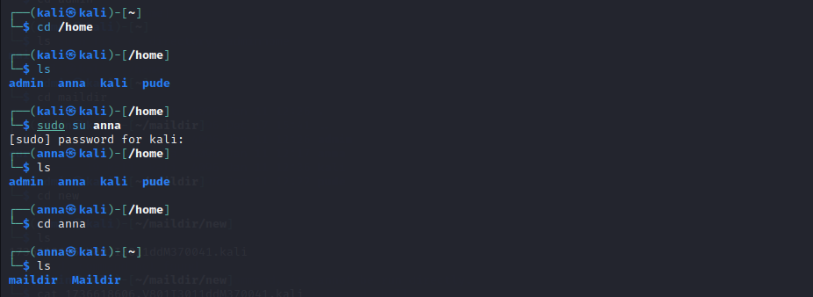

Step 6: The log file associated with the email transactions is founded to the another user Anna as the receiver of the email which is /home/anna/maildir/new.
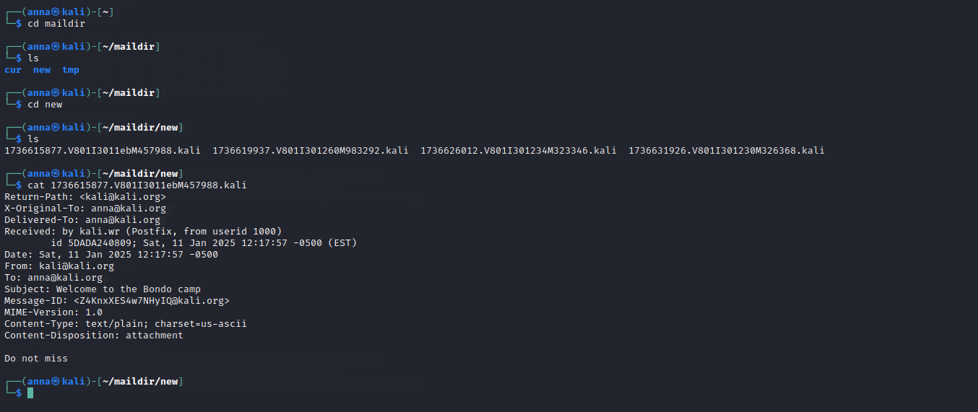

Conclusion: We are able to track email details obtained from email header analysis to the log file since there is no mismatch of any details, all details are correct then no any malicious appears.

